Case study 1: Feature sets and descriptions
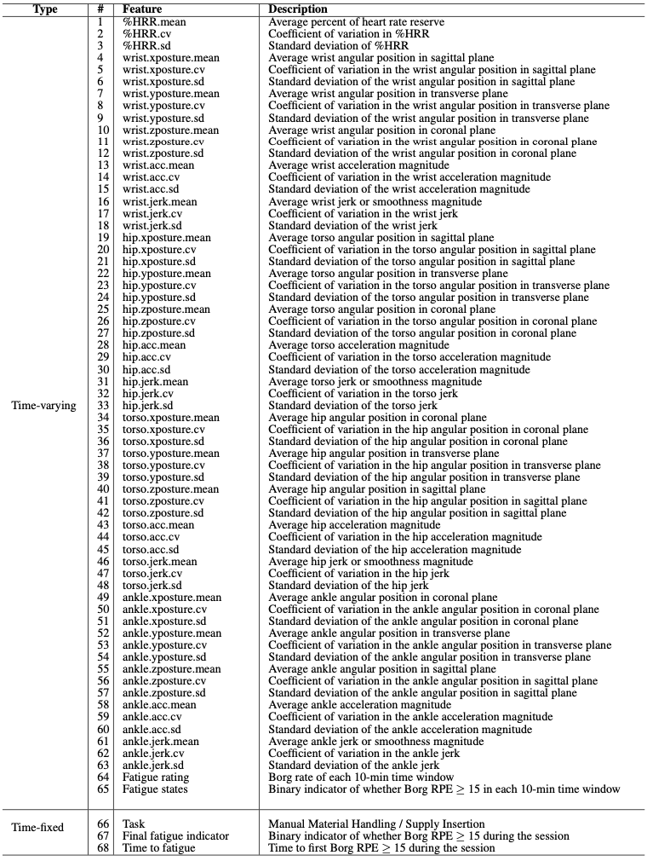
Original dataset adapted from:
Maman, Z. S., Yazdi, M. A. A., Cavuoto, L. A., & Megahed, F. M. (2017). A data-driven approach to modeling physical fatigue in the workplace using wearable sensors. Applied ergonomics, 65, 515-529.
Case study 2: Feature sets and descriptions
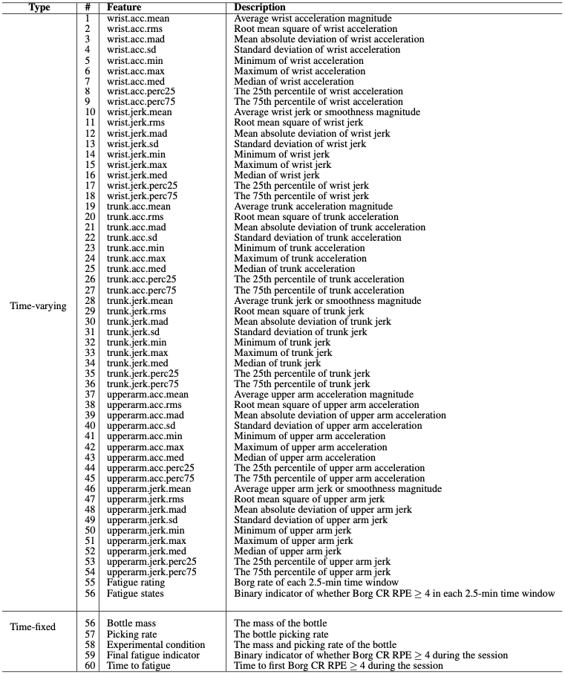
Original dataset adapted from:
Vahedi, Z., Kazemi Kheiri, S., Hajifar, S., Ragani Lamooki, S., Sun, H., Megahed, F. M., & Cavuoto, L. A. (2023). The relationship between ratings of perceived exertion (RPE) and relative strength for a fatiguing dynamic upper extremity task: A consideration of multiple cycles and conditions. Journal of occupational and environmental hygiene, 20(3-4), 136-142.

